Lab Assignment 6.3: AI-Based Code Completion – Classes, Loops, and Conditionals
Name: Suvikhyath Thirunahari
Roll No.: 2503B05202
Date:05-11-2025

Lab Objectives:
- Explore AI auto-completion features for Python class definitions, loops, and conditionals.
- Analyze how AI generates and suggests logic for core Python constructs.
- Evaluate completeness and correctness of AI-generated code.

Lab Outcomes:
- Use AI tools to generate / complete Python classes and methods.
- Understand and analyze AI-generated loops for iterative tasks.
- Generate conditional logic using prompt suggestions.
- Critically evaluate AI-assisted code for correctness and clarity.

Task #1 — Classes
Use AI to complete a Student class with constructor and display_details() method.

Python Code Generated by AI:
class Student:
def __init__(self, name, roll_no, branch):
self.name = name
self.roll_no = roll_no
self.branch = branch

def display_details(self):
print("---- Student Details ----")
print(f"Name : {self.name}")
print(f"Roll No : {self.roll_no}")
print(f"Branch : {self.branch}")

# Creating an object and calling the method
student1 = Student("Suvikhyath", "2503B05202", "CSE")
student1.display_details()

Screenshot:

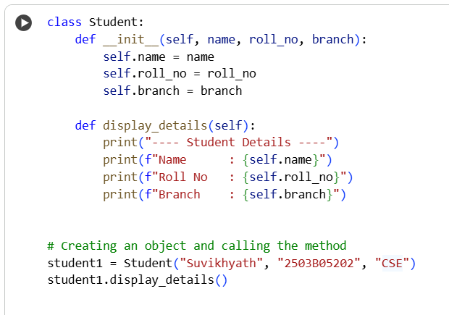

Expected Output:
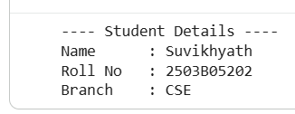
Task #2 — Loops
Prompt AI to complete a function printing the first 10 multiples of a number using a loop.

Python Code Generated by AI:
def print_multiples(num):
print(f"First 10 multiples of {num}:")
for i in range(1, 11): # Loop runs from 1 to 10
print(num * i)
print_multiples(5)

Screenshot:

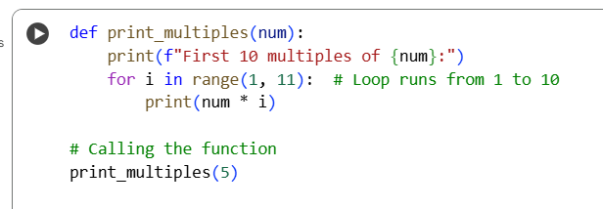

Output:
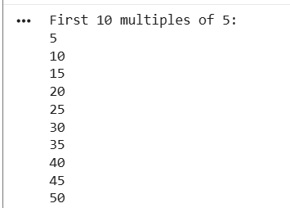
Task #3 — Conditional Statements
Ask AI to write nested if-elif-else conditionals to classify age groups.

Python Code Generated by AI:
def classify_age(age):
if age < 0:
return "Invalid age"
if age <= 12:
return "Child"
elif age <= 19:
return "Teen"
elif age <= 35:
return "Young Adult"
elif age <= 59:
return "Adult"
else:
return "Senior Citizen"
# Testing the function
print(classify_age(8)) # Child
print(classify_age(17)) # Teen
print(classify_age(28)) # Young Adult
print(classify_age(45)) # Adult
print(classify_age(70)) # Senior Citizen

Output Screenshot:

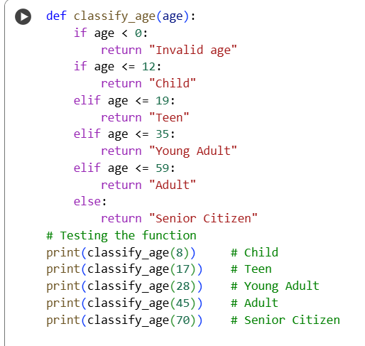
Output:
Age classification function with meaningful explanation
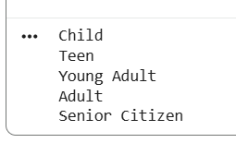

Task #4 — For and While Loops

Generate a sum_to_n() function to calculate the sum of first n numbers.
Python Code Generated by AI:
def sum_to_n_for(n):
"""Calculate sum of first n numbers using a FOR loop"""
total = 0

for i in range(1, n + 1):

total += i

return total

def sum_to_n_while(m):

"""Calculate sum of first m numbers using a WHILE loop"""

total = 0

i = 1

while i <= m:

total += i

i += 1

return total

Screenshot:

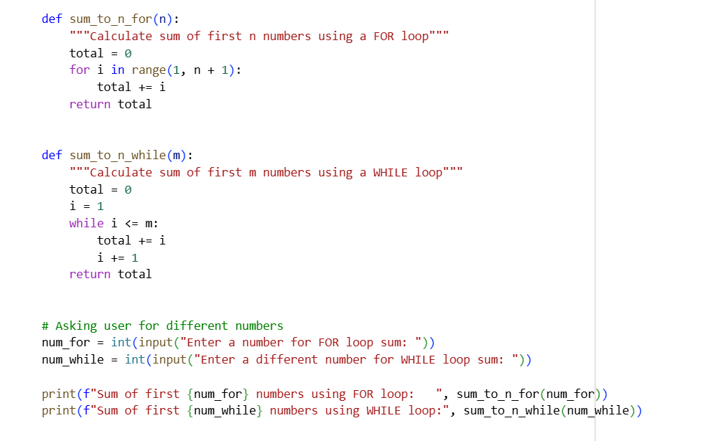

Expected Output:
Function output with explanation and loop usage
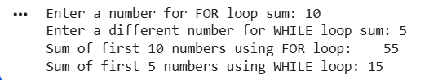
Task #5 — Class (BankAccount)
Use AI to build a BankAccount class with deposit(), withdraw(), and balance() methods.
Python Code Generated by AI:
class BankAccount:
def __init__(self, owner, balance=0):
"""Initialize account with owner and starting balance"""
self.owner = owner
self.balance = balance

def deposit(self, amount):
"""Deposit money into account"""
if amount > 0:
self.balance += amount
print(f"✅ Deposit Successful: ₹{amount}")
else:
print("⚠️ Deposit amount must be greater than zero.")

def withdraw(self, amount):
"""Withdraw money from account"""
if amount <= 0:
print("⚠️ Withdrawal amount must be greater than zero.")
elif amount > self.balance:
print("❌ Withdrawal failed: Insufficient balance.")
else:
self.balance -= amount
print(f"✅ Withdrawal Successful: ₹{amount}")

def check_balance(self):
"""Display current account balance"""
print(f"💰 Current Balance: ₹{self.balance}")
print("====== Welcome to Python Bank ======")

name = input("Enter your name: ")
initial_amount = float(input("Enter opening balance: "))

account = BankAccount(name, initial_amount)

while True:
print("\n------ MENU ------")
print("1. Deposit")
print("2. Withdraw")
print("3. Check Balance")
print("4. Exit")

choice = input("Choose an option (1/2/3/4): ")

if choice == '1':
amount = float(input("Enter deposit amount: "))
account.deposit(amount)

elif choice == '2':
amount = float(input("Enter withdrawal amount: "))
account.withdraw(amount)

elif choice == '3':
account.check_balance()

elif choice == '4':
print("🟢 Thank you for using Python Bank!")
break

else:
print("❌ Invalid choice, please try again.")

Screenshot:
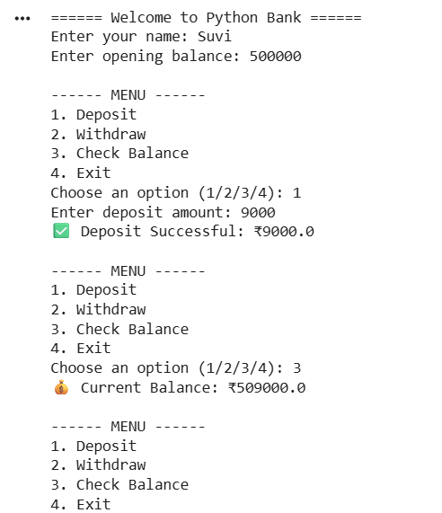
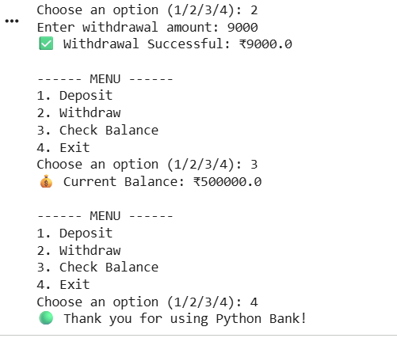
Conclusion:
AI-assisted code generation was used to create Python programs involving classes, loops, and conditional statements. By providing clear prompts, the AI generated functional code for multiple tasks, including class-based operations, looping structures, and conditional logic. The exercise helped improve understanding of how AI tools suggest code, automate repetitive logic, and reduce development time, while still requiring human validation for accuracy and correctness. Overall, this experiment demonstrated how AI can effectively support problem-solving and enhance coding productivity.

